 | Mendeleev Commun., year, issue, pages | 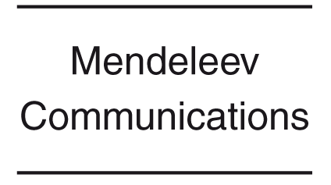
 | Mendeleev Commun., year, issue, pages | 00/0000
Title, with the first word only capitalised
Forename I. Surname 1,*ª Forename I. Surname 2,ª Forename I. Surname 3^{b} and Forename I. Surname 3^{a,b}
ª Affiliation 1, Including Department's Name For the Universities, Postal Code City, Country.
Fax: +7 495 000 0000; e-mail: mail@site.org
^{b} Affiliation 2, Postal Code City, Country

The summary should be an account of the discovery being announced (one to three sentences). It must clearly indicate the content that makes the communication important or urgent.  (Insert summary here) | All communications should include a graphical abstract for illustrated contents list. It should be a diagram, picture or scheme carefully chosen to allow a casual reader to appreciate the nature of the work presented in the communication. Maximum size 40×85 mm.  (Insert graphical abstract here)
Keywords: keyword 1, keyword 2, keyword 3, keyword 4, keyword 5, keyword 6. The authors should provide 5-10 keywords for indexing purposes.

The main text of the article should appear here. The first paragraph is not intendent.
(Headings and subheadings are not allowed in articles submitted to Mendeleev Communications.)
Communications should be restricted to the central urgent theme. Authors should use minimum of illustrations and schemes and avoid extensive historical introduction, super fluous experimental detail, physical data and detailed reasoning. Authors are encouraged to include, briefly, important details relevant to the proof of the reliability of the results. DOC and DOCX files with the manuscripts are preferable. It would be helpful if Figures could be additionally submitted in a common vector or a high resolution raster format as separate files.
- Reagents and conditions: i, glyoxal, Na₂SO₄, CH₂Cl₂, 0 °C; ii, (COD)Pd(Me)Cl, CH₂Cl₂, room temperature.
(Insert Scheme here.) Graphics must fit a one- or two-column format on the Journal page (One column 8.5 cm, two column 17.8 cm.). All artwork should be produced with a drawing program such as ChemDraw. http://www.mendcomm.org/download/guidline2.pdf

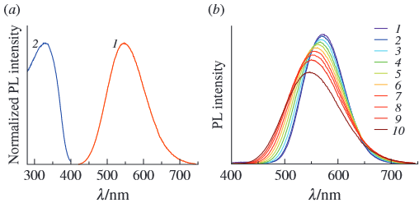
- (a) Normalized (1) emission and (2) excitation spectra of solid 1·CH₂Cl₂ at 298 K. (b) Temperature-dependent emission spectra ( λ_{ex} = 320 nm) of solid 1·CH₂Cl₂ recorded at (1) 77, (2) 100, (3) 125, (4 ) 150, (5) 175, (6) 200, (7) 225, (8) 250, (9) 275 and (10) 300 K. See Guidelines for Illustrations.
(Insert Figure here.)
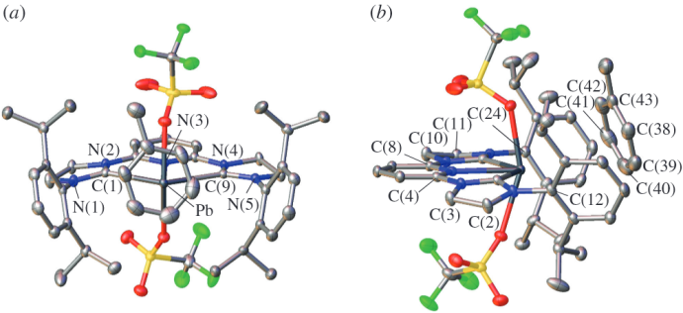
- Solid-state structure of complex 7∙PhMe shown (a) from the front and (b) from the side. Ellipsoids are shown at the 50% probability level; co-crystallized hexane and hydrogen atoms are omitted for clarity. For selected bond lengths and angles, see Online Supplementary Materials. See Guidelines for Illustrations.

- Reagents and conditions: i, bromide 1, AgOTf, TMU, CH₂Cl₂, room temperature, 20 h; ii, 80% aq. AcOH, 70 °C, 2 h, then Ac₂O/Py; iii, 0.1 M MeONa/MeOH, 30 min, then 0.1 M aq. NaOH.

- Table Caption. ((Note: Please do not include the table in a textbox or frame))
Entryª | Sample | C/mol dm^{–3} | a/Å^{b} | a/deg | T/°C | t/min^{b}
1 | Compoundª | 10.5 | 10.02 | 15 | 100 | 1
2 | Compound | 0.2^{с} | 12.42 | 18 | 120 | 5
3 | Compound | 0.8 | 16.69 | 25 | 150 | 10
ª Excess repeating information is taken in the header or in the footnote below the table. ^{b} All units of measure are presented in the SI system, and using a slash. ¢ All values are aligned to the decimal point.

Crystallography in the Manuscript. Details of the data collection should be given in a footnote (see example below).
Online Supplementary Materials
Supplementary data associated with this article can be found in the online version at doi:
References
- R. Nifosì, B. Mennucci and C. Filippi, Phys. Chem. Chem. Phys., 2019, 21, 18988; https://doi.org/10.1039/C9CP03722E.
- D. S. Kuliukhina, A. S. Malysheva, A. D. Averina, E. N. Savelyev, B. S. Orlinson, I. A. Novakov and I. P. Beletskaya, Russ. J. Org. Chem., 2023, 59, 2107; https://doi.org/10.1134/S1070428023120072.
- R. A. Fernandes, P. Kumar and N. Chandra, in Comprehensive Organometallic Chemistry IV, 2022, vol. 8, pp. 632‒679; https://doi.org/10.1016/B978-0-12-820206-7.00079-2.
- J. Koetz and S. Kosmella, Polyelectrolytes and Nanoparticles, Springer, Berlin, 2007; https://doi.org/10.1007/978-3-540-46382-5.
- M. J. Sharp and W. R. Moore, Jr., Patent US 10792292 B2, 2020; https://patentimages.storage.googleapis.com/40/e2/0a/88f66c1aefc647/US10792292.pdf.
- A. V. Kustov, D. V. Batov and T. R. Usacheva, Kalorimetriya rastvorov neelektrolitov (Calorimetry of Non-electrolyte Solutions), ed. V. A. Sharnin, Krasand, Moscow, 2017 (in Russian); http://i.uran.ru/webcab/system/files/bookspdf/kalorimetriya-rastvorov-neelektrolitov/kalorimetriya.pdf.
- H. Aripin, S. Sutisna, N. Busaeri and S. Sabchevski, in Proceedings of 10th International Conference on Chemical Science and Engineering ICCSE 2021, November 19–21, 2021, pp. 65‒72; https://doi.org/10.1007/978-981-19-4290-7.
- [dataset] NREL, Best Research-Cell Efficiency Chart, 2023; https://www.nrel.gov/pv/cell-efficiency.html.

Self-citations should not exceed 30%. All authors should be listed for each reference. Particular attention should be paid to the correct spelling and completeness of all bibliographic information. Journal titles should be abbreviated according to the Chemical Abstracts Service Source Index (CASSI). Where an authoritative abbreviation cannot be located, the full title should be given. Titles of books must be given in full, together with publisher's name and location. Russian sources should be transliterated. For translated Russian journals, it is necessary to indicate only the English version citation. Inclusion of several citations (a,b,c, etc.) in one reference is not allowed. The final reference list is required to be complied using auto-numbering. For each reference, it is necessary to provide DOI index or URL address according to the above examples.

The required length of the articles ranges from two to three printed pages.
Please be aware, our template aims to give you an idea of what your article will look like, however the final version will be formatted during production and may look different in keeping with our house style.
Formatting – please delete this box prior to submission.

Crystal data for 5f. C₅H₅N₆F₃O₄ (M = 270.13), monoclinic, space group P21/n, a = 11.430(12), b = 5.630(7) and c = 15.64(2) Å, β = 103.10(10)°, V = 980(2) Å³, μ(MoKα) = 1.714 mm^{–1}. Analysis was performed at 295(2) K on an Xcalibur 3 diffractometer by standard procedure (graphite monochromated MoKα radiation, ω-scanning). On the angles 4.36<θ<65.23° total of 7324 reflections were measured, 1660 unique reflections (Rint = 0.0390), 1507 reflections with I > 2σ(I). The structure was solved and refined using the SHELXTL program package. The structure was defined by direct statistical methods and refined by full-matrix anisotropic approximation for F² for all non-hydrogen atoms with ShelXL program. The hydrogen atoms were localized by direct method and refined in the isotropic approximation. GOOF = 1.007, S = 1.038; final R values: R₁ = 0.0443, wR₂ = 0.1361 [I > 2σ(I)]; R₁ = 0.0476, wR₂ = 0.1396 (all data). Residual electronic density max/min was 0.312/ –0.247 eÅ^{–3}. CCDC 1529899 contains the supplementary crystallographic data for this paper. These data can be obtained free of charge from The Cambridge Crystallographic Data Centre via http://www.ccdc.cam.ac.uk.

